General information about the crops
Lemon
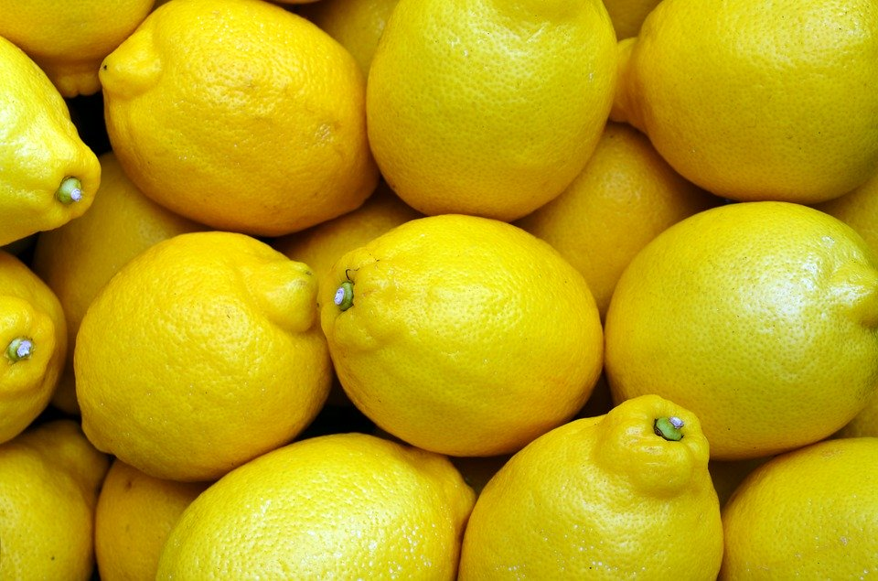

- General information
Citrus is an important fruit crop. Lemon is one of the important category of citrus. It is mainly known for its pulp and juice throughout the world. Dierent citrus fruits are used throughout the world as food or juice. In central India, Nagpur santra is grown on a large scale. Mandarin Production states are Assam, Dibrugarh and Brahmaputra valley. In India Citrus cultivation is done on an area of about 923 thousand hectare with annual production of 8608 thousand metric tons. In Punjab citrus is grown on 39.20 hectares of land.
- Climate
Temp(MIN/MAX)  20-25 | Rainfall(MIN/MAX)  75-200
Sowing Temperature  20-25 | Harvesting Temperature  25-30

- Popular variety with their Yield.
Variety | Yield
Pau baramass | 25
eureka | 25

- Land preparation
Land should be ploughed, cross ploughed and leveled properly. Planting is done on terraces against slopes in hilly areas. High density planting is also possible in such areas.

- Sowing- best season for planting is july - august

- Seed rate – minimum plant density of 208/acre should be maintained
Treatment- Spacing between plants should be kept between 4.5×4.5. Pits of size 60×60×60cm should be dug for planting seedlings.
10Kg of Farmyard Manure and 500g of single superphosphate should be applied to pits while planting.

- Fertilizer Requirement
Age of crop(year) | Well decomposed cow dung (kg/tree) | Urea (gm/tree)
First to three year | 5-20 | 100-300
Seven to Nine | 25-50 | 400-500
Four to Six | 60-90 | 600-800
Ten and above | 100 | 600-1800

Nutrient requirement
Age of crop (Year) | Well decomposed cow dung (kg/tree) | Nitrogen (gm/tree)
First to three year | 5-20 | 50-150
Seven to Nine | 25-50 | 200-250
Four to Six | 60-90 | 300-400
Ten and above | 100 | 400-800

When age of crop is 1-3year, apply well decomposed cow dung@5-20kg per Tree and Urea@100300gm per Tree. For 4-6year old crop, apply well decomposed cowdung@25-50kg and Urea@100300gm per Tree. For 7-9year old crop, apply Urea@600-800gm per tree and well decomposed cow dung@60-90kg per Tree. When crop is 10year old or above, apply cowdung@100kg or Urea@800-1600gm per tree. Apply whole amount of cow dung during December month whereas apply Urea in two parts; apply first of Urea in February, and second dose in April-May month. At time of applying first dose of Urea, apply whole dose of SSP fertilizer. If fruit drop is observed, to control excessive fruit drop, take spray of 2,4-D@10gm in 500Ltr of water. Take first spray in March end, then in April end. Repeat the spray in August and September end. If cotton is planted in nearby field of citrus, avoid spraying of 2,4-D, instead take spray of ga3

- Weed Control- Weed can be controlled by hand-hoeing and also controlled by chemically, use glyphosate@1.6litre per 150 litre of water. Use glyphosate only on weeds not on crop plants.

- Irrigation- Lemon requires irrigation at regular intervals. Lifesaving irrigation should be given in winters and summers. Irrigation is necessary for Flowering, Fruiting and proper plant growth. Over irrigation may also leads to diseases like Root rot and collar rot. High frequency irrigation is beneficial. Salty water is injurious for crop plants. Partial drying out of soil in spring may not affect plants.

- Plant protection –

Leaf miner: Larvae inside the upper or lower surface of young and newly emerged leaves are curled and look distorted. Young trees show a reduction in growth due to leaf miner. Best management for leaf miner is to leave it alone and let the natural enemies to feed upon them and parasitize their larvae.
It can also be controlled by spraying Phosphomidon Monocrotophos @1.5ml per 3-4 times fortnightly. Pheromone traps are also available for detecting leaf miner moths

Citrus Psylla: These are juice sucking pests. Damage is mainly caused by nymphs. It injects a plant toxin liquid which burns foliage and skin of fruit. Leaves curl and fall o prematurely.
It can be controlled by pruning of diseased plants, burning them. Spraying of Monocrotophos-0.025% or carbaryl- 0.1% can also be helpful.

Aphids & Mealy Bugs: They are small sap sucking pests. Bugs are present on the underside of leaves. Synthetic pyritheriods or pest oil can be used to control aphids and bugs.

- Harvesting
On attaining proper size, shape along with attractive color having TSS to Acid ratio of 12:1, kinnow fruits is ready for harvest. Depending upon variety fruits are generally ready for harvesting in Mid- January to Mid- February. Do harvesting at proper time as too early or too late harvesting will give poor quality.

- Storage- After harvesting, wash fruits with clean water then dip fruits in Chlorinated water@2.5ml per Liter water and then partially dried them. To improve appearance along with to maintain good quality, do Citrashine wax coating along with foam. Then these fruits are dried under shade and then packing is done. Fruits are packed in boxes

